Packet Tracer - Troubleshooting Static Routes

1. Topology

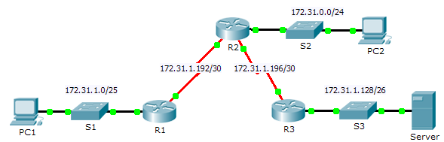

1. Addressing Table

|  |  |  |  |  |
| --- | --- | --- | --- | --- |
| Device | Interface | IPv4 Address | Subnet Mask | Default Gateway |
| R1 | G0/0 | 172.31.1.1 | 255.255.255.128 | N/A |
| S0/0/0 | 172.31.1.194 | 255.255.255.252 | N/A |
| R2 | G0/0 | 172.31.0.1 | 255.255.255.0 | N/A |
| S0/0/0 | 172.31.1.193 | 255.255.255.252 | N/A |
| S0/0/1 | 172.31.1.197 | 255.255.255.252 | N/A |
| R3 | G0/0 | 172.31.1.129 | 255.255.255.192 | N/A |
| S0/0/1 | 172.31.1.198 | 255.255.255.252 | N/A |
| PC1 | NIC | 172.31.1.126 | 255.255.255.128 | 172.31.1.1 |
| PC2 | NIC | 172.31.0.254 | 255.255.255.0 | 172.31.0.1 |
| Server | NIC | 172.31.1.190 | 255.255.255.192 | 172.31.1.129 |

1. Objectives

Part 1: Locate the Problem

Part 2: Determine the Solution

Part 3: Implement the Solution

Part 4: Verify That the Issue Is Resolved

1. Background

In this activity, PC1 reports that they cannot access resources on the server. Locate the problem, decide on an appropriate solution and resolve the issue.

1. Locate the Problem

PC1 cannot access files on the server. Locate the problem using the appropriate **show** commands on all routers and any troubleshooting commands on the PCs that you have learned from previous chapters.

What are some of the troubleshooting commands on routers and PCs that can be used to identify the source of the problem?

_______________________________________________________________________________________

1. Determine the Solution

After you have located the problem that is preventing PC1 from accessing files on the server, fill in the table below.

|  |  |
| --- | --- |
| Problem | Solution |
|  |  |
|  |  |

1. Implement the Solution
   * 1. If there are any misconfigured static routes, you must remove them before the correct ones can be added to the configuration.
     2. Add any missing static routes by configuring directly attached routes.
2. Verify That the Issue Is Resolved
   * 1. Ping from PC1 to the server.
     2. Open a web connection to the server. After you correctly identify and implement the correct solution to the problem, you will receive a message in the web browser when you connect to the server.
3. Suggested Scoring Rubric

|  |  |  |
| --- | --- | --- |
| Activity Section | Possible Points | Earned Points |
| Part 1: Locate the Problem | **2** |  |
| Part 2: Determine the Solution | **8** |  |
| **Packet Tracer Score** | **90** |  |
| **Total Score** | **100** |  |